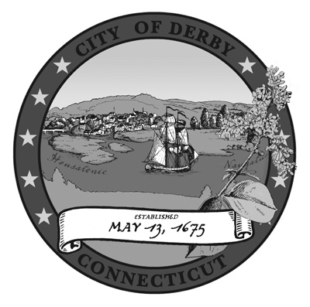
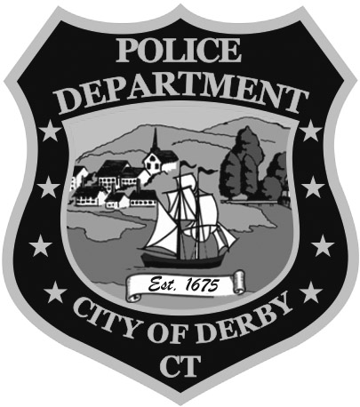

Derby Police Commission
Derby, Connecticut 06418
Commission Traffic Authority
Sam Pollastro, Chairman Sam Pollastro
Thomas Lenart Thomas Lenart
Richard Bartholomew Richard Bartholomew
Jessica Chueka, Secretary

14 JAN 19

The Derby Police Commission will not hold its Regular Meeting on
14 JAN 19 due to a lack of quorum.

Sam Pollastro
Chairman,
Derby Police Commission

